**Review Meeting- 037**

Gaurang Garg

BioPhotonica Lab, Centre for Biomedical Engineering, IIT Delhi

2025-09-29 (Monday)

**Title:** Overview of Fourier Ptychography Microscopy

**Abstract:** Fourier Ptychography Microscopy (FPM) is a computational imaging technique to tackle the problems of conventional microscopy by post measurement data processing. It is an iteration-based optimization problem that gives high resolution, wide field-of-view and quantitative phase recovery. In this report, I present basic concept and theory of FPM and how it is implemented via algorithms.

# 1. **Introduction**

The intrinsic problem in the conventional microscopy imaging is the trade-off between resolution and field-of-view (FOV) – To extract finer details of the sample, we have to reduce the area of the sample under consideration, or we get coarse details with large area of sample covered. [1] This technique takes this problem from domain of hardware and design modifications to the domain of computation to give high resolution output without giving up on FOV and vice versa.

This technique holds tremendous potential in the implementations of quantitative phase imaging. [2] The algorithm used to implement the technique is highly derived from the parent technique called Ptychography which is a phase retrieval technique.

The primary question is the need for this technique, as mentioned earlier, the conventional optical systems have encountered some problems and cannot be further improved via physical alterations to the setup or the optical components [3].

## 1.1. **Phase Information**

Light as an electromagnetic wave can be described by a complex amplitude function which has two key pieces of information: amplitude and phase. The amplitude is associated with the energy intensity of the wave and phase represents spatial distribution or the time delay in propagation. The object (sample) represented by a complex object function interacts with the wave and the transmitted wave carries crucial phase information of the object, such as the refractive index and morphology information. Conventional microscopes have photo-detectors of some kind which can measure the intensity of the light and consequently lose the crucial phase information of the object.

## 1.2. **Aberration Induced Artifacts**

The objective lens of a microscope acts as a low pass filter with passing frequency determined by the numerical aperture (NA). High spatial frequency corresponds to diffraction at large angles. This limits the resolution of the optical system [4]. To decrease the minimum resolvable distance (increasing the resolution) higher NA objective lens must be used which would give rise to aberration induced artifacts. A better resolution (larger NA) implies a smaller FOV and a shorter depth-of-focus that makes aberration correction harder.

## 1.3. **Resolvable Pixels**

The number of pixels (essentially, the information or the degrees of freedom) that can be recorded are given by the space bandwidth product (SBP). The trade-off between resolution and FOV presents itself physically in this problem as: to increase the number of pixels by detecting more and covering a wide surface in image plane or to reduce the size of one pixel and again increasing the number of pixels in a fixed area. Typical lenses give about 10 megapixels of resolvable pixels [3]. Higher SBP is highly desirable for biomedical applications [5].

## 1.4. **Labeling the Sample**

Most biological cells are transparent, owing to their low absorption coefficient. The intensity contrast under conventional microscopes is poor. The spatial distribution of refractive index is non-uniform and consequently the primary information of the object function comprising entirely of phase. Again, current sensors record only the intensity of the incoming optical field and the phase information gets lost. To overcome this, we can label our samples (stain) with a chemical reagent or a fluorochrome. The process has its own limitations mainly: long preparation time, phototoxicity, photobleaching etc.

## 1.5. **Lensless** **Imaging**

To altogether eliminate the limitations imposed by the system like those intrinsic to the physical lenses, lensless imaging techniques like Coherent Diffraction Imaging (CDI) were developed which computationally recovered the lost phase information from intensity measurements. The algorithms for this are noise sensitive and prone to get stuck in the local minimum. Scanning version of CDI: Ptychography which works by capturing multiple diffraction patterns through the scan of a localized illumination on an extended object. Redundant information in the overlap regions of the illuminated spots is exploited for phase retrieval. Mechanical scanning may lead to stitching artifacts.

As an advancement and subsequently the solution to above-discussed problems FPM has emerged as an effective technique for Quantitative Phase Imaging and better Resolution with Wide FOV.

# 2. **Concept of FPM**

## 2.1. **Principle**

FPM uses the conventional microscope setup; low NA objective lens is used to acquire wide FOV data. The technique combines two imaging techniques: synthetic aperture synthesis and phase retrieval. Synthetic aperture synthesis as a concept is used to bypass the conventional resolution limit imposed on a far-field diffraction. In FPM, we synthesize the pupil aperture in Fourier plane to bypass resolution set by objective lens.

The insight of FPM is that the objective can only collect light at certain angles (NA), however, parts of the scattering light can also be collected due to light matter interaction (Rayleigh or Mie scattering considering the feature size of sample). Instead of conventionally starting with HR and stitching together for a larger FOV, FPM uses low NA objective to take advantage of its innate large FOV and stitches together low resolution (LR) images in Fourier space to recover HR.

For Phase recovery, these LR images act as constraints in Fourier space on the high-resolution complex valued object Function. The multiangle illumination of the object is essentially scanning the Fourier space and thus eliminates the need for mechanical scanning and successive refocusing.

## 2.2. **Implementation**

The setup comprises of an LED array mounted under the sample. A conventional microscope with low NA objective lens, and a monochromatic imaging sensor. The sample is illuminated successively from multiple angles, contributing to relative displacement between the spectrum of sample and aperture of objective lens due to Fourier translation theorem. For each angle, sensor records low-resolution data. This multi-angle dataset is further processed iteratively to obtain our desired HR image. A schematic of the FPM setup is shown in Fig. 1 [3].

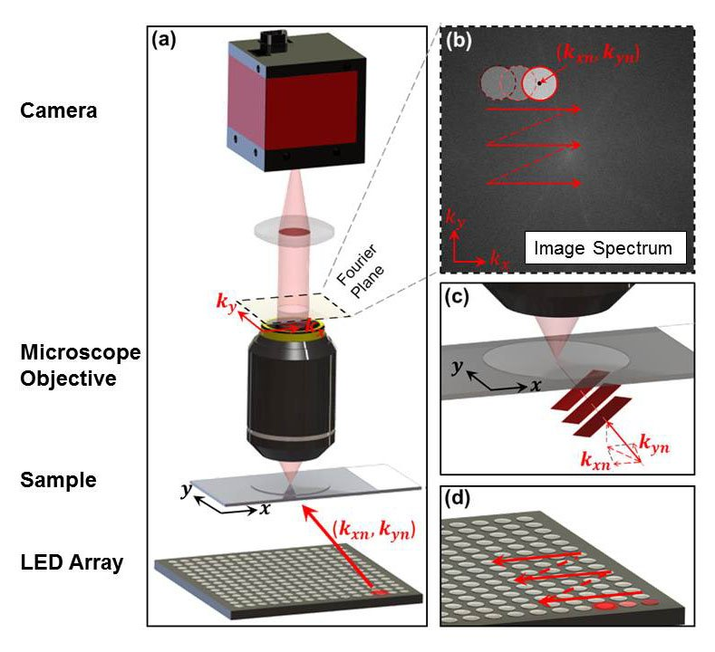

Figure 1 (a) Schematic of the FPM setup (b) The objective’s Pupil function imposes a well-defined constraint in the Fourier space. (c) Constraint is panned across the Fourier space to reflect the angular variation of angle-varied illuminations (Fourier translation theorem) (d) LED array for multi-angled illuminations

## 2.3. **Theory**

For each $LED_{m,n}$   (row m, column n) there’s an associated, illumination wave vector $\left(k_{x,m,n} , k_{y,m,n}\right)$ . Assuming that the incident light is an ideal plane wave and the sample is relatively thin, the transmitted wave field from sample is $O\left(x , y\right).e^{\left(i , k_{x,m,n}x,ik_{y,m,n}y\right)}$ , where $O\left(x , y\right)$ is sample's transmission function and $P\left(k_{x} , k_{y}\right)$ is Pupil Function**.** Coordinate transform of pupil function in spatial domain, termed Coherent Transfer Function acts as a low pass filter of an imaging system. The Fourier transform of the object function,

|  |  |
| --- | --- |
| $$\begin{aligned}\tilde{O}\left(k_{x},k_{y}\right)=F\left\{O\left(x,y\right)\right\}=\iint{O\left(x,y\right)}.e^{-i\left(xk_{x}+yk_{y}\right)}dxdy \end{aligned}$$ | (1) |

Image sensor captures an LR intensity image $I_{m,n}$  given by

|  |  |
| --- | --- |
|  | (2) |
|  | (3) |

FPM attempts to eliminate or minimize the variations in amplitude between simulation patterns and captured images iteratively: Non-convex optimization

|  |  |
| --- | --- |
|  | (4) |

## 2.4. **Algorithm**

The algorithm to carry out the optimization problem comprises of following steps:

1. An initial HR complex amplitude guess of the pupil function and sample spectrum, $P_{o}\left(k_{x} , k_{y}\right)and\overset{\sim }{O_{o}}\left(k_{x} , k_{y}\right)$  respectively. Initial guess of pupil function is a circular shape due to objective design and zero phase (nature of CTF). Up-sampled LR image is taken as first guess for sample spectrum.
2. The exit wave at the Fourier plane can be estimated by multiplication

|  |  |
| --- | --- |
| $$φ_{m,n}^{e}\left(k_{x},k_{y}\right)=\tilde{O_{o}}\left(k_{x}-k_{x,m,n} ,k_{y}-k_{y,m,n} \right).P_{o}\left(k_{x},k_{y}\right)$$ | (5) |

And the simulated LR image on the image plane is inverse Fourier Transform of it:

|  |  |
| --- | --- |
| $$φ_{m,n}^{e}\left(x,y\right)=F^{-1}\{φ_{m,n}^{e}\left(k_{x},k_{y}\right)\}$$ | (6) |

It would have some amplitude and Phase information.

1. The modulus of the simulated LR image is replaced by the square root of the actual measurement, and the phase remains unchanged.

|  |  |
| --- | --- |
|  | (7) |

1. The modified LR image is then used to update the corresponding spectrum region of sample estimate in the Fourier domain.

|  |  |
| --- | --- |
| $\tilde{O}\left(k_{x},k_{y}\right)=F\{φ_{m,n}^{u}\left(x,y\right)\}$. $P\left(k_{x},k_{y}\right)+φ_{m,n}^{e}\left(k_{x},k_{y}\right)[1-P\left(k_{x},k_{y}\right)]$ | (8) |

Single iteration is completed when all the captured images are used to update corresponding parts of the sample spectrum in Fourier domain. $i$  iterations are repeated until the solution converges in the limits of an error metric defined by

|  |  |
| --- | --- |
|  | (9) |

The modification in the LR image does not update the pupil or object function in the beginning. There are multiple frameworks to update these functions that can be implemented.

# **References**

1. G. Zheng, C. Shen, S. Jiang, P. Song, and C. Yang, "Concept, implementations and applications of Fourier ptychography," Nat Rev Phys **3**, 207–223 (2021).

2. X. Ou, R. Horstmeyer, C. Yang, and G. Zheng, "Quantitative phase imaging via Fourier ptychographic microscopy," Opt. Lett., OL **38**, 4845–4848 (2013).

3. A. Pan, C. Zuo, and B. Yao, "High-resolution and large field-of-view Fourier ptychographic microscopy and its applications in biomedicine," Rep. Prog. Phys. **83**, 096101 (2020).

4. J. W. Goodman, *Introduction to Fourier Optics* (Roberts and Company Publishers, 2005).

5. G. Zheng, R. Horstmeyer, and C. Yang, "Wide-field, high-resolution Fourier ptychographic microscopy," Nature Photon **7**, 739–745 (2013).